
KJ's Educational Institute

KJ COLLEGE OF ENGINEERING AND MANAGEMENT RESEARCH
Affiliated to Savitribai Phule Pune University (SPPU), Approved by Govt. of Maharashtra, Recognized by AICTE, New Delhi.
DEPARTMENT OF COMPUTER
ENGINEERING
YEAR 2023-2024
SEMESTER – II
PROJECT BASED LEARNING
– II [210258]
PROJECT TITLE:
J.A.R.V.I.S DESKPOT ASSISTANT

GROUP MEMBERS ROLL NO.

ROLL NO | NAME | BATCH
7 | Nikita Nigade | S4
8 | Akanksha  Nimbalakar | S4
18 | Saurabh Patil | S4
19 | Shubhangi Patil | S4
20 | Anniruddha Pawar | S4

FACULTY – Ms. ARTI G. GHULE
HOD – Dr Nikita Kulkarni

TABLE OF CONTENT
- INTRODUCTION
ABSTRACT
PROJECT AIMS AND OBJECTIVES
BACKGROUND OF PROJECT
OPERATION ENVIRONMENT
- SYSTEM ANALYSIS
SOFTWARE REQUIREMENT SPECIFICATION
EXISTING SYSTEAM
SOFTWARE TOOL USED
- SYSTEM DESIGN
SYSTEAM FLOW DIAGRAM
4.SYSTEM IMPLEMENTATION
MODULE DESCRIPTION
SCREEN SHOT
5.SYSTEM TESTING
UNIT TESTING
INTEGRATION TESTING
6. CONCLUSION & FUTURE SCOPE

CHAPTER NO-1 : INTRODUCTION
ABSTRACT

J.A.R.V.I.S (Just A Rather Very Intelligent System) Desktop Assistant is an intelligent and comprehensive desktop assistant designed to provide users with efficient and personalized assistance within the desktop environment. The assistant aims to automate tasks, retrieve information, facilitate communication, and enhance productivity through its wide range of functionalities.

IT encompasses several key aspects. Firstly, it focuses on task management, allowing users to efficiently organize their schedules, set reminders, and manage their to-do lists. It streamlines task completion and helps users stay organized.
Secondly, J.A.R.V.I.S Desktop Assistant excels in information retrieval and search capabilities. It can retrieve information from various sources, including the internet and local files, and present it in a concise and organized manner. Users can rely on J.A.R.V.I.S to provide answers to their questions, perform web searches, and access relevant knowledge.
Communication is another vital aspect of J.A.R.V.I.S Desktop Assistant. It facilitates email management, enabling users to send and receive messages, manage contacts, and schedule appointments. By integrating with popular email clients and calendar applications, J.A.R.V.I.S streamlines communication workflows.

The assistant also focuses on file and document management, allowing users to easily locate and organize their files and documents on the desktop. With J.A.R.V.I.S, users can quickly search for specific files, categorize them into folders, and gain easy access to frequently used documents.
J.A.R.V.I.S Desktop Assistant offers customization and personalization options, allowing users to tailor the assistant's behavior, appearance, and preferences to their specific needs. This flexibility ensures that J.A.R.V.I.S aligns with individual workflows and preferences.
In summary, J.A.R.V.I.S Desktop Assistant is an intelligent and comprehensive solution that combines task automation, information retrieval, communication facilitation, personalized recommendations, voice interaction, context awareness, customization, and security. It aims to enhance productivity, streamline workflows, and provide users with a seamless and efficient desktop assistant experience.

Project Aims And Objectives
he J.A.R.V.I.S Desktop Assistant project is an intelligent and comprehensive assistant designed to enhance productivity and streamline workflows within the desktop environment. Inspired by the fictional AI assistant from the Iron Man movies, J.A.R.V.I.S (Just A Rather Very Intelligent System), this project aims to bring similar capabilities to real-life users.

The J.A.R.V.I.S Desktop Assistant serves as a virtual companion, providing personalized assistance, information retrieval, task management, communication facilitation, and more. It leverages advanced technologies such as artificial intelligence, natural language processing, and machine learning to understand user inputs, interpret commands, and respond with relevant and helpful information.

With J.A.R.V.I.S Desktop Assistant, users can efficiently manage their tasks, set reminders, and organize their schedules. They can retrieve information from various sources, including the internet and local files, allowing quick access to relevant knowledge. The assistant also streamlines communication by managing email, contacts, and appointments.

The project emphasizes user experience, offering voice and natural language interaction for a seamless and intuitive interface. By understanding spoken commands and responding verbally or through text, J.A.R.V.I.S Desktop Assistant provides a hands-free and efficient way to interact with the system.

Security and privacy are paramount in the J.A.R.V.I.S Desktop Assistant project. Measures are implemented to safeguard user data, including encryption and secure data handling practices, ensuring confidentiality and protecting against unauthorized access.

The project envisions continuous improvement and expansion, with the future scope encompassing advancements in AI, automation, integration with external applications and services, and personalization based on user preferences. J.A.R.V.I.S Desktop Assistant aims to become a reliable and indispensable companion in the desktop environment, empowering users to be more productive and efficient.

By combining intelligence, automation, and user-centric design principles, the J.A.R.V.I.S Desktop Assistant project aspires to transform the desktop experience and provide users with a powerful and personalized assistant at their fingertips.
Problem Statement

J.A.R.V.I.S Deskpot Assistant is to develop an intelligent and efficient desktop assistant that can perform a wide range of tasks to assist users in their daily activities. The assistant should be able to understand natural language commands and queries, respond with relevant and accurate information, and execute various tasks effectively.
The specific objectives of J.A.R.V.I.S Deskpot Assistant include:
Natural Language Understanding: The assistant should be capable of comprehending user commands and queries in natural language, including voice input. It should be able to accurately interpret the user's intent and extract relevant information from the input.
Task Execution: J.A.R.V.I.S should be able to perform a variety of tasks efficiently, such as managing schedules and reminders, setting alarms, sending emails, making phone calls, searching the web, providing weather updates, playing music, and more. It should have the ability to integrate with other applications and systems to accomplish these tasks.
Context Awareness: The assistant should maintain context awareness throughout the conversation, allowing it to understand references to previous queries or commands. It should be able to provide relevant and personalized responses based on the user's preferences and historical interactions.
Personalization: J.A.R.V.I.S should adapt to individual users' preferences and behavior over time, learning from their interactions and providing personalized recommendations and suggestions. It should be able to customize its responses and actions based on user profiles and preferences.

User Interface: The assistant should have a user-friendly interface that allows users to interact with it seamlessly. This can include a desktop application, a web-based interface, or integration with popular communication platforms.

Security and Privacy: J.A.R.V.I.S Deskpot Assistant should ensure the security and privacy of user data. It should adhere to strict data protection practices and comply with relevant privacy regulations to safeguard sensitive information.

Scalability and Reliability: The assistant should be designed to handle a large number of users simultaneously and should be highly reliable, minimizing downtime and disruptions in service.

By addressing these objectives, J.A.R.V.I.S Deskpot Assistant aims to provide users with a powerful and efficient tool to enhance productivity and simplify their daily tasks through intelligent automation and assistance.

Objectives
Task Automation: J.A.R.V.I.D Desktop aims to automate repetitive tasks and streamline processes to improve efficiency and productivity. It should be able to perform tasks such as managing schedules, setting reminders, organizing files, and performing system maintenance.

Information Retrieval: The assistant should have the ability to retrieve information quickly and accurately from various sources, including the internet, local files, databases, and other relevant resources. It should provide relevant and up-to-date information in response to user queries or commands.

Personalization: J.A.R.V.I.D Desktop seeks to provide a personalized experience to users by learning from their preferences, behavior, and historical interactions. It should be able to adapt its responses and actions to individual user profiles and provide tailored recommendations and suggestions.

Voice and Natural Language Interaction: J.A.R.V.I.D Desktop aims to support voice-based commands and natural language understanding, allowing users to interact with the assistant using their voice. It should be capable of accurately interpreting spoken commands, transcribing voice inputs, and responding verbally or through text.
Application Integration: The assistant should integrate with various applications and services available on the desktop environment. It should be able to interact with email clients, calendar systems, productivity tools, web browsers, media players, and other relevant software to perform tasks and retrieve information.

BACKGROUND 0F PROJECT

The J.A.R.V.I.S (Just A Rather Very Intelligent System) Desktop Assistant project is inspired by the fictional assistant featured in the Marvel Cinematic Universe, particularly in the Iron Man movies. J.A.R.V.I.S, developed by Tony Stark, is an advanced AI-powered assistant that assists him in various tasks and provides real-time information.

The project aims to create a similar desktop assistant that combines natural language processing, machine learning, and task automation to simplify and enhance the user's daily activities. The J.A.R.V.I.S Desktop Assistant will be designed to run on popular desktop operating systems such as Windows, macOS, and Linux.

The assistant will provide a user-friendly interface for seamless interaction through voice input and text commands. It will incorporate voice recognition technology to convert spoken commands into text and use advanced natural language processing algorithms to comprehend and interpret user queries accurately. Machine learning techniques will be utilized to improve the assistant's understanding and generate appropriate responses.

The J.A.R.V.I.S Desktop Assistant will have task automation capabilities to streamline repetitive and time-consuming tasks. It will automate actions such as file management, email handling, and calendar scheduling based on user preferences and behavior. The assistant will also offer system control features, allowing users to adjust settings, control volume, manage power options, and perform other system-related tasks.

Information retrieval will be a key aspect of the assistant, providing real-time data such as weather updates, news articles, and stock prices. The assistant will integrate with relevant APIs and web scraping techniques to retrieve and present this information to the user in a personalized and intuitive manner.

Furthermore, the J.A.R.V.I.S Desktop Assistant project will emphasize extensibility and customization. It will provide an API or SDK for developers to extend its functionality and allow users to customize the assistant's behavior, appearance, and additional features. This will enable users to tailor the assistant according to their preferences and integrate it with other services and applications.

Overall, the J.A.R.V.I.S Desktop Assistant project aims to create an intelligent and versatile assistant that simplifies tasks, enhances productivity, and provides an enhanced user experience on desktop systems.

OPERATING ENVIRONMENT

The operating environment of the J.A.R.V.I.S Desktop Assistant project refers to the specific conditions and requirements for running and using the assistant software effectively. The operating environment typically includes hardware, operating systems, software dependencies, and network connectivity. Here are the key aspects of the operating environment for the J.A.R.V.I.S Desktop Assistant:

Hardware Requirements:

Processor: The assistant should run smoothly on standard desktop processors like Intel Core i5 or higher.
Memory (RAM): A minimum of 4GB RAM is recommended, but higher RAM capacity will improve performance.
Storage: The assistant requires sufficient storage space for the application itself, datasets, and other resources.
Microphone: For voice input, a functioning microphone is necessary to capture the user's voice commands.
Operating System Compatibility:
The J.A.R.V.I.S Desktop Assistant should be compatible with popular desktop operating systems, including:
Windows: Windows 10, Windows 8, Windows 7, or later versions.
macOS: macOS Mojave, macOS High Sierra, or later versions.
Linux: Ubuntu, Fedora, or other Linux distributions.

Software Dependencies:

Python: The assistant is built using Python programming language, so a compatible version of Python should be installed.
Python Libraries: The project may rely on various Python libraries for natural language processing, machine learning, speech recognition, and system control. Examples include NLTK, spaCy, TensorFlow, PyTorch, and more.
Speech Recognition and Text-to-Speech: APIs or libraries for speech recognition (e.g., Google Cloud Speech-to-Text) and text-to-speech synthesis (e.g., Google Text-to-Speech) may be used.
External Services: Integration with external services (e.g., weather APIs, news APIs) may require appropriate API keys or access credentials.
Network Connectivity:
Internet connectivity is required to access external APIs, retrieve real-time information, and perform web scraping.
A stable network connection is recommended to ensure smooth operation and timely responses from external services.
It's important to note that specific hardware and software requirements may vary depending on the implementation and features of the J.A.R.V.I.S Desktop Assistant. It's recommended to review and update the operating environment requirements based on the chosen programming language, libraries, and services used in your project.

CHAPTER 2: SYSTEM ANALYSIS

SOFTWARE REQUIREMENT SPECIFICATION

The system analysis phase of the J.A.R.V.I.S. Desktop Assistant project involves a comprehensive evaluation of the requirements and functionality of the system. Here are the key aspects of the system analysis:
To provide a software requirement specification for a J.A.R.V.I.S desktop assistant project, we need to outline the functional and non-functional requirements of the system. Here's an example of what the requirements might look like:

Functional Requirements:

Speech Recognition:
- The assistant should be able to accurately recognize and understand spoken commands from the user.
- It should support multiple languages and dialects.
Natural Language Processing (NLP):
- The assistant should be capable of understanding natural language queries and commands.
- It should be able to interpret user intent and context.
Voice Synthesis:
The assistant should have the ability to generate human-like speech responses.
- It should support multiple voices and speech styles.
Task Execution:
- The assistant should be able to perform various tasks based on user requests, such as:
- Providing weather forecasts.
- Setting reminders and alarms.
- Searching the web for information.
- Sending emails or text messages.
- Managing calendars and schedules.
- Controlling smart home devices.
- Playing music or videos.
- Opening and interacting with other applications.
- Providing system status and information.
User Interface:
- The assistant should have a user-friendly interface, allowing users to interact via voice or text input.
- It should provide visual feedback, such as displaying text or relevant information.
- The interface should be customizable and responsive to different screen sizes.
Integration:
- The assistant should be able to integrate with external services and APIs to fetch data or perform specific tasks.
- It should support popular third-party applications and services, such as email providers, calendars, music streaming platforms, etc.

Non Functional Requirements

Performance:
- The assistant should respond quickly to user commands and provide timely results.
- It should handle concurrent user interactions efficiently.
- The system should have minimal latency in speech recognition and synthesis.
Security:
- User data and personal information should be securely stored and protected.
- The assistant should authenticate users and ensure their privacy.
- It should adhere to data protection and privacy regulations.
Reliability:
- The assistant should be highly reliable, minimizing errors and crashes.
- It should have backup and recovery mechanisms to handle failures gracefully.
Scalability:
- The system should be scalable to accommodate a growing user base and increasing workload.
- It should be able to handle high traffic and concurrent requests.
Compatibility:
- The assistant should be compatible with major operating systems, such as Windows, macOS, and Linux.
- It should work across different devices, including desktops, laptops, and tablets.
- The software should be compatible with common web browsers and their latest versions.

These are just some examples of the software requirements for a J.A.R.V.I.S desktop assistant project. You can further refine and expand these requirements based on the specific goals and functionalities you have in mind for your assistant.

EXISTING VS PROPOSED SYSTEM

Existing System:
Problem on existing system:
Limited Functionality: The current version of the J.A.R.V.I.S. Desktop Assistant might have limited capabilities compared to the desired functionalities. tasks.
natural Language Understanding (NLU) Challenges: The system's NLU capabilities may not be robust enough to accurately understand and interpret user commands and queries. This can lead to misunderstandings and incorrect responses, affecting the overall user experience.
Lack of Contextual Understanding: The assistant may struggle to maintain context across multiple interactions

Proposed system:
The proposed system for the J.A.R.V.I.S Desktop Assistant project aims to develop a powerful and intuitive virtual assistant inspired by the J.A.R.V.I.S concept from the Marvel movies. The system will provide voice-controlled interactions and assist users in performing various tasks efficiently and conveniently. Here's an outline of the proposed system:
Speech Recognition:
The system will incorporate advanced speech recognition technology to accurately capture and interpret user commands and queries.
It will support multiple languages and dialects to cater to a diverse user base.

Natural Language Processing (NLP):
The assistant will employ robust NLP algorithms to understand and interpret natural language queries and commands.
It will analyze user intent and context to provide accurate and relevant responses.
Voice Synthesis:
The system will utilize state-of-the-art voice synthesis techniques to generate human-like speech responses.
It will offer a variety of voices and speech styles to personalize the user experience.
Task Execution:
The assistant will be capable of performing a wide range of tasks based on user requests, including:
Providing weather forecasts and current information.
Setting reminders, alarms, and timers.
Conducting web searches and retrieving relevant information.
Sending emails and text messages.
Managing calendars, schedules, and to-do lists.
Controlling smart home devices and automation systems.
Playing music, videos, and podcasts.
Opening and interacting with other applications and software.
Providing system status and information.
User Interface:
The assistant will feature a user-friendly interface for seamless voice or text-based interactions.
It will offer visual feedback to display text-based responses or relevant information.
The interface will be customizable and responsive across different screen sizes and resolutions.
Integration:
The system will integrate with external services, APIs, and platforms to fetch data or perform specific tasks.
It will support popular third-party applications and services, such as email providers, calendars, music streaming platforms, etc.
Security and Privacy:
The assistant will prioritize the security and privacy of user data and personal information.
It will employ robust authentication mechanisms and adhere to data protection regulations.
Performance and Scalability:
The system will be designed for high performance, ensuring quick response times and minimal latency in speech recognition and synthesis.
It will be scalable to accommodate a growing user base and handle increased workload.
Compatibility:
The assistant will be compatible with major operating systems, including Windows, macOS, and Linux.
It will support various devices, such as desktops, laptops, and tablets.
The software will be compatible with common web browsers and their latest versions.
These are the proposed features and functionalities for the J.A.R.V.I.S Desktop Assistant project. Further refinement and development will be required to bring the system to life and deliver an efficient and user-friendly virtual assistant experience.

SOFTWARE TOOL USED:-

Python: PyCharm, Anaconda, Visual Studio Code
Java: Eclipse, IntelliJ IDEA, NetBeans
C#: Visual Studio, Visual Studio Code
JavaScript: Visual Studio Code, Sublime Text, Atom
Speech Recognition and Voice-to-Text Conversion:
Select a speech recognition tool or API to convert spoken commands into text.
Examples:
Google Cloud Speech-to-Text
Microsoft Azure Speech Service
Mozilla DeepSpeec

CHAPTER 3:

SYSTEM DESIGN

E-DIAGRAM

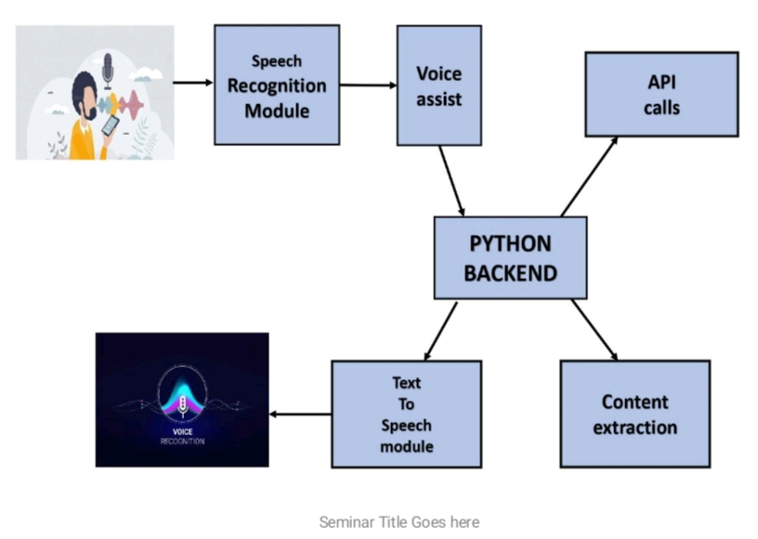

there is a speech communication between the user and the device. The device interacts with the skill (or application). Internally, two main elements, namely the skill interface and the skill service communicate through JSON encoded messages. We offer our students different alternatives for [27] [development. The easiest alternative (although currently not available for Spanish language)

SYSTEAM FLOW DIAGRAM

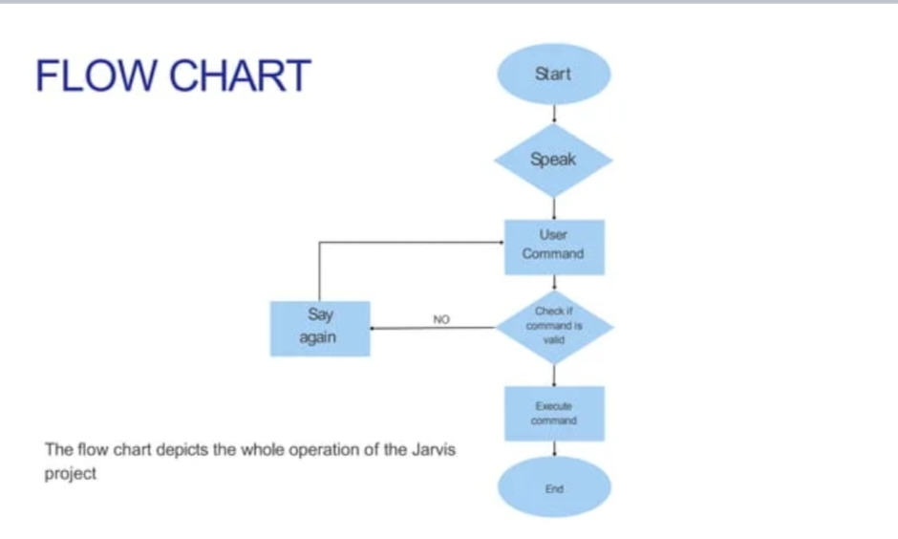

DATA FLOW DIAGRAM

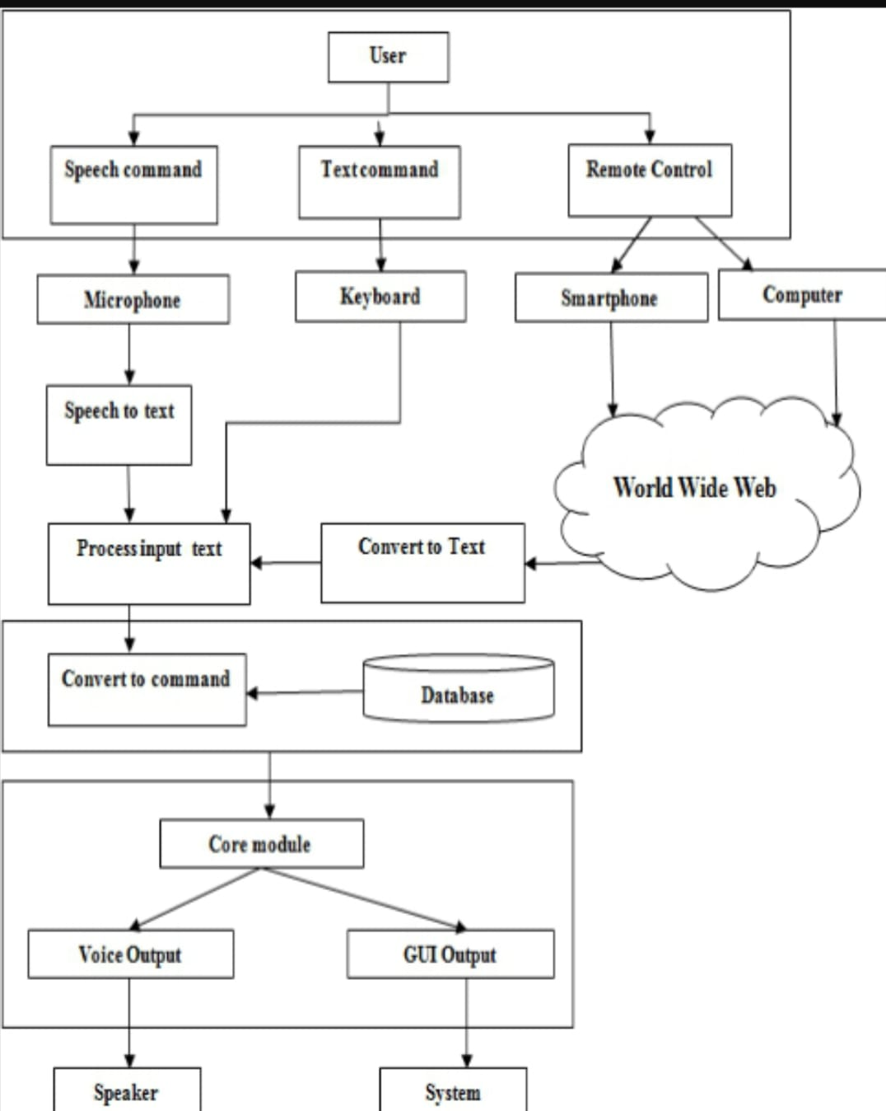

CHAPTER 4
SYSTEM IMPLEMENTATION

Define Project Scope and Goals:
Clearly define the project scope, including the specific features and functionalities to be implemented.
Set clear goals and objectives for the project to guide the development process.
Design the Architecture:
Design the system architecture, considering the components and modules required to support the desired functionalities.
Determine the interaction flow between the user interface, speech recognition, NLP, task execution, and integration components.
Speech Recognition:
Choose a suitable speech recognition library or API to integrate into the system.
Implement the necessary logic to capture and process user voice input.
Train or configure the speech recognition system to recognize different languages and dialects accurately.
Natural Language Processing (NLP):
Select an NLP library or framework to process and interpret user commands and queries.
Develop algorithms to extract user intent and context from natural language input.
Implement techniques such as entity recognition and sentiment analysis to enhance the understanding of user input.
Voice Synthesis:
Utilize a voice synthesis library or tool to generate human-like speech responses.
Implement logic to convert text-based responses into synthesized speech.
Customize the voice synthesis parameters, such as voice selection, tone, and speed, to enhance the user experience.
Task Execution:
Develop the necessary modules and logic to handle different tasks based on user requests.
Integrate with external services and APIs to perform specific actions, such as weather data retrieval, email sending, calendar management, etc.
Implement error handling and feedback mechanisms to handle cases where tasks cannot be completed successfully.
User InterfaceDesign and develop a user-friendly interface for interacting with the assistant.
Implement voice input and text input mechanisms for user interaction.
Design the visual display of responses, feedback, and relevant information.
Integration:
Integrate the system with external services and APIs to fetch data or perform tasks.Implement the necessary authentication and authorization mechanisms to access third-party services securely.

Security and Privacy:
Implement security measures to protect user data and personal information.
Ensure compliance with data protection regulations and best practices for handling sensitive data.
Testing and Quality Assurance:
Perform comprehensive testing to verify the functionality

SCREENSHOT : CODE
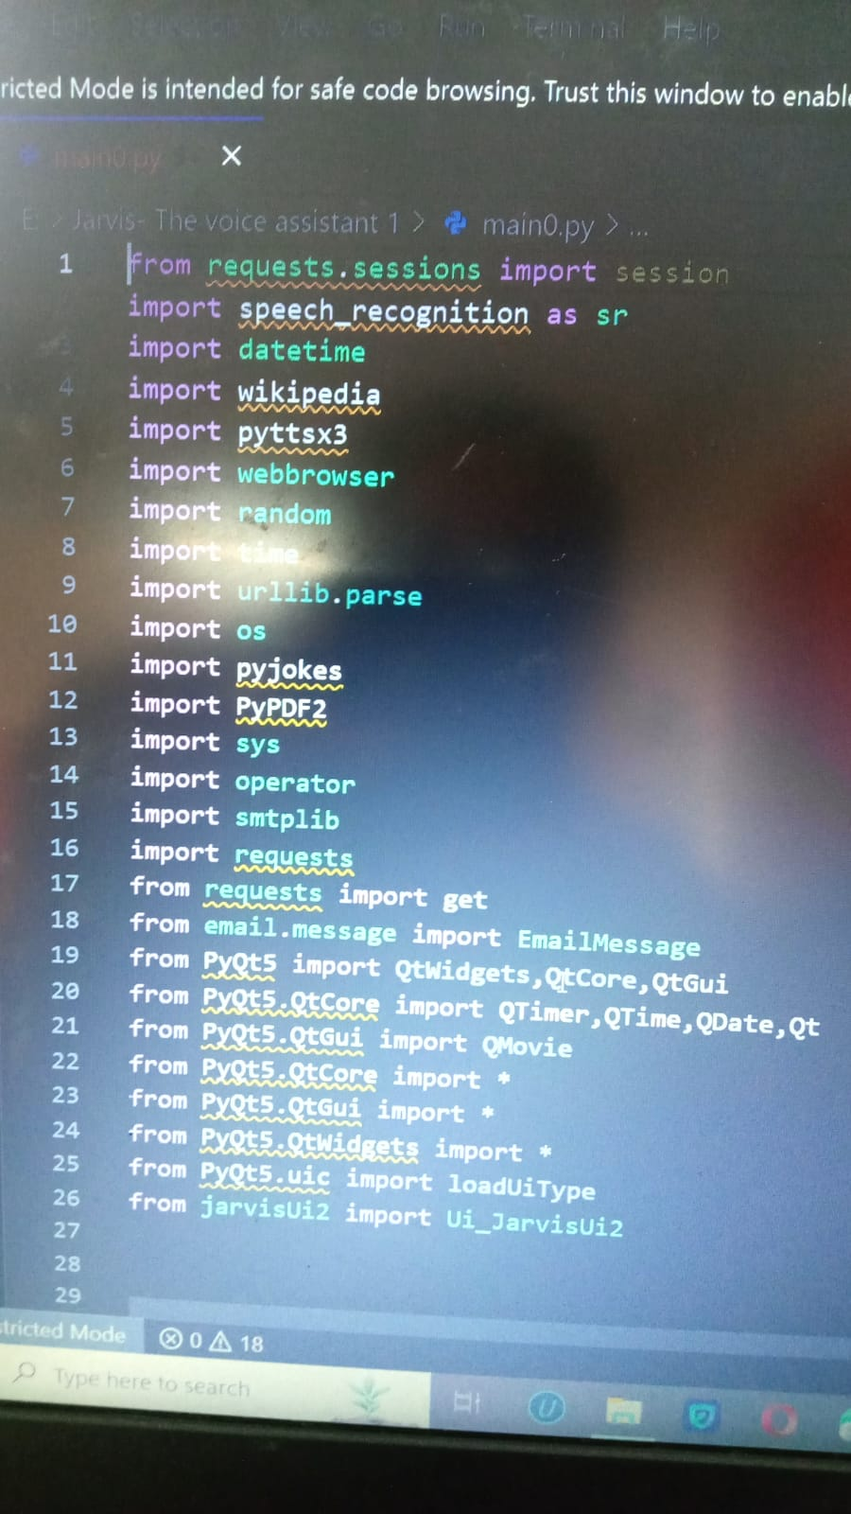

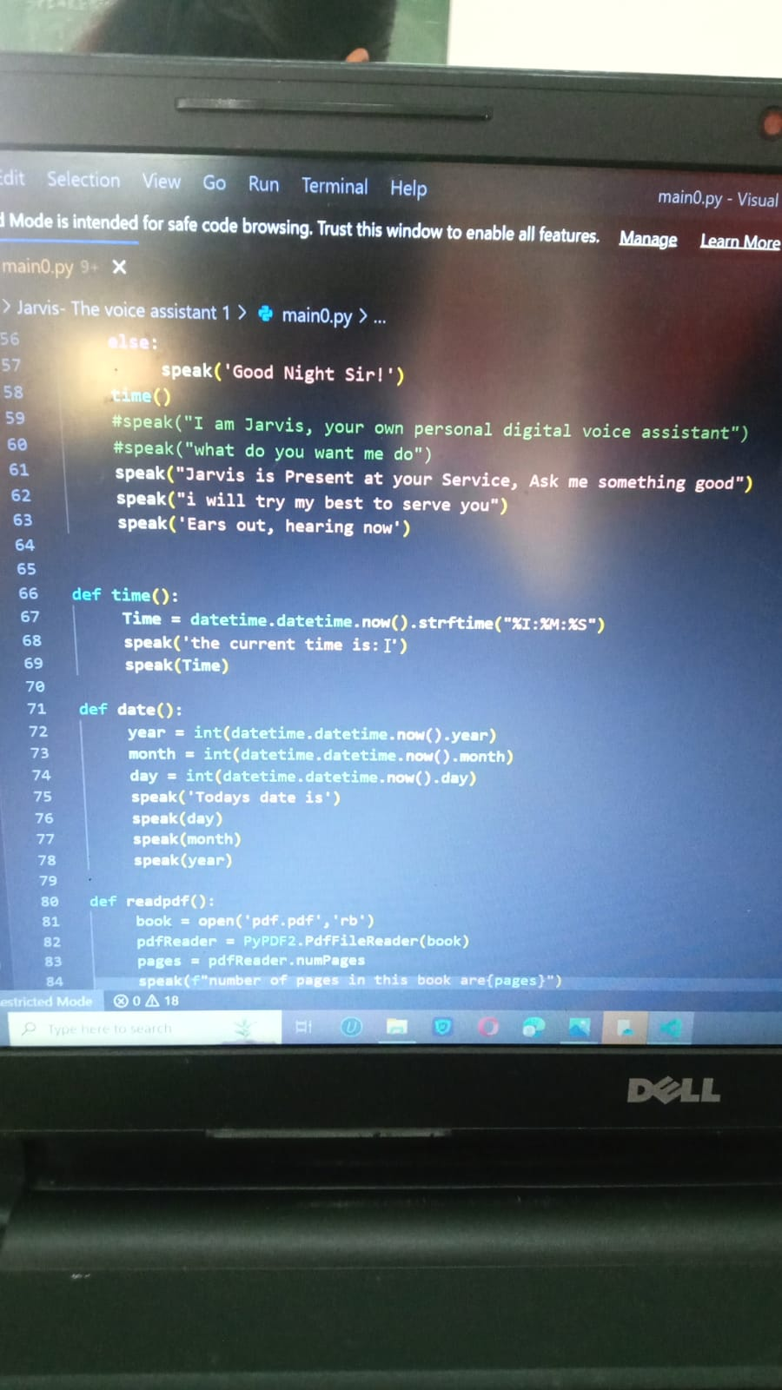

OUTPUT

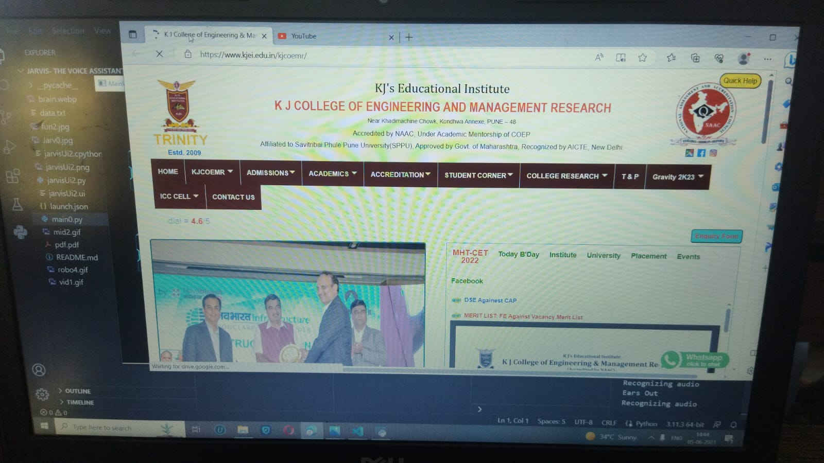

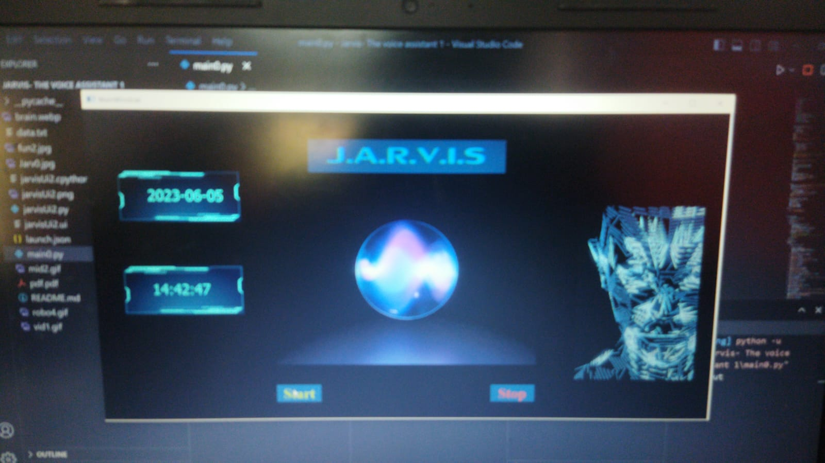

CHAPTER 5
SYSTEM TESTING

System testing of J.A.R.V.I.S Desktop Assistant involves verifying and validating its functionalities, performance, and reliability.
The objective is to ensure that the assistant meets the specified requirements and performs as expected in the desktop environment. Here are some key aspects of system testing for J.A.R.V.I.S Desktop Assistant
Functional Testing: This involves testing each functionality of the assistant to ensure it performs the intended tasks correctly. It includes testing features such as task management, information retrieval, communication, file management, personalized recommendations, voice interaction, and customization.
Integration Testing: J.A.R.V.I.S Desktop Assistant may integrate with various desktop applications and services. Integration testing ensures seamless communication and data exchange between the assistant and these external systems. It verifies that integration points are properly implemented and data is correctly transmitted and received.
User Interface Testing: The user interface (UI) of J.A.R.V.I.S Desktop Assistant should be intuitive, user-friendly, and visually appealing. UI testing involves verifying the design, layout, and responsiveness of the UI components, ensuring they function correctly and provide a smooth user experience.
Performance Testing: Performance testing evaluates how well J.A.R.V.I.S Desktop Assistant handles various workloads and performs under normal and peak usage conditions. It includes testing response times, processing speed, memory usage, and resource utilization to identify any performance bottlenecks or limitations.
Usability Testing: Usability testing focuses on assessing the overall user experience of J.A.R.V.I.S Desktop Assistant. It involves observing users interacting with the assistant to evaluate its ease of use, intuitiveness, and effectiveness in fulfilling user needs. Feedback from users is gathered to identify areas of improvement.
Voice Recognition and Natural Language Processing Testing: If J.A.R.V.I.S supports voice interaction, extensive testing is necessary to ensure accurate voice recognition and proper interpretation of spoken commands. This involves testing different accents, speech patterns, and languages to ensure reliable understanding and response.
Context Awareness Testing: Since J.A.R.V.I.S aims to maintain context throughout interactions, testing is conducted to verify that the assistant accurately recalls previous queries or commands and provides appropriate responses based on the context.
Security and Privacy Testing: J.A.R.V.I.S Desktop Assistant should adhere to security best practices and protect user data. Security and privacy testing involves assessing vulnerabilities, data handling practices, encryption mechanisms, and access control to ensure the assistant safeguards user information

CHAPTER 6
CONCLUSION AND FUTURE SCOPE

CONCLUSION :

project aims to provide users with an intelligent and comprehensive assistant within the desktop environment. Throughout its development, the project has focused on enhancing task management, information retrieval, communication, file management, personalized recommendations, voice interaction, context awareness, customization, and security.
Security and privacy have been key considerations in the development of J.A.R.V.I.S Desktop Assistant. Robust measures are implemented to protect user data, including encryption and secure data handling practices.
Looking into the future, the project holds exciting potential for advancements and enhancements. .
Overall, the J.A.R.V.I.S Desktop Assistant project seeks to provide users with a powerful and intelligent assistant that simplifies tasks, provides timely information, and enhances productivity within the desktop environment. Through its comprehensive set of features and ongoing development, it aims to offer an efficient and

FUTURE SCOPE

Artificial Intelligence (AI) and Machine Learning (ML) Advancements: J.A.R.V.I.S Desktop Assistant can leverage advancements in AI and ML to further enhance its capabilities. This includes improving natural language understanding and processing, context awareness, personalized recommendations, and proactive assistance based on user behavior and preferences. Advanced Voice Recognition and Natural Language Processing: Future implementations of J.A.R.V.I.S Desktop Assistant can benefit from improved voice recognition technologies, allowing for more accurate and efficient interaction with users. Natural language processing capabilities can also be enhanced to understand complex queries and provide more sophisticated responses.

Enhanced Automation and Intelligent Workflows: J.A.R.V.I.S Desktop Assistant can become more intelligent in automating tasks and streamlining workflows. It can proactively identify routine or repetitive tasks and suggest automated solutions, saving users time and effort. The assistant can also learn from user preferences and patterns to provide more proactive and personalized assistance. Advanced Integration with Applications and Services: Future implementations can expand the integration capabilities of J.A.R.V.I.S Desktop Assistant, allowing it to seamlessly interact with a wider range of desktop applications and services. This includes deeper integration with productivity tools, collaboration platforms, content management systems, and more, enabling users to access and manage their work across various platforms and applications.



